SEMESTER ONE
Papers written by
Australian Maths
Software

YEAR 12, Unit 3

MATHEMATICS APPLICATIONS
REVISION 2
2016

Section One
(Calculator–free)

Name: _________________________________

Teacher: ________________________________

TIME ALLOWED FOR THIS SECTION

Reading time before commencing work: 5 minutes
Working time for section: 50 minutes

MATERIAL REQUIRED / RECOMMENDED FOR THIS SECTION

To be provided by the candidate
Standard items: pens, pencils, pencil sharpener, highlighter, eraser, ruler.

IMPORTANT NOTE TO CANDIDATES
No other items may be taken into the examination room. It is your responsibility to ensure
that you do not have any unauthorised notes or other items of a non–personal nature in the
examination room. If you have any unauthorised material with you, hand it to the supervisor
before reading any further.

To be provided by the supervisor

Question/answer booklet for Section One.
A formula sheet which may also be used for Section Two.
Structure of this examination

 | Number of questions available | Number of questions to be answered | Working time (minutes) | Marks available | Percentage of exam
Section One  Calculator—free | 6 | 6 | 50 | 52 | 35
Section Two  Calculator—assumed | 9 | 9 | 100 | 98 | 65
Total marks |  |  |  | 150

Instructions to candidates

1. The rules for the conduct of this examination are detailed in the Information
Handbook. Sitting this examination implies that you agree to abide by these rules.

2. Write your answers in the Question/Answer booklet.

3. You must be careful to confine your responses to the specific questions asked and to
follow any instructions that are specific to a particular question.

4. Spare pages are provided at the end of this booklet. If you need to use them, indicate
in the original answer space where the answer is continued i.e. give the page number.

5. Show all your working clearly. Your working should be in sufficient detail to allow your
answers to be checked readily and for marks to be awarded for reasoning. Incorrect
answers given without supporting reasoning cannot be allocated any marks. For any
question or part question worth more than two marks, valid working or justification is
required to receive full marks. If you repeat an answer to any question, ensure that you
cancel the answer you do not wish to have marked.

6. It is recommended that you do not use pencil, except in diagrams.

7. The Formula Sheet is not to be handed in with your Question/Answer booklet.

1. (4 marks)
Between 2000 and 2009, it has been found in America that there is a very high correlation (r =0.947) between the per capita cheese consumption and the number of people who died tangled in their bed sheets.
NB per capita means per person.
http://www.tylervigen.com/spurious-correlations

Jeremy concluded that if it was possible to slow down cheese consumption, then it would reduce the number of people who died tangled in their bedsheets.

(a) Comment on Jeremy’s conclusion. (2)

(b) Suggest a possible cause for such a high but spurious correlation to exist. (2)

2. (7 marks)
The following chart shows the birth rate per 1000 women of child bearing age in five different countries against their average annual earning capacity.
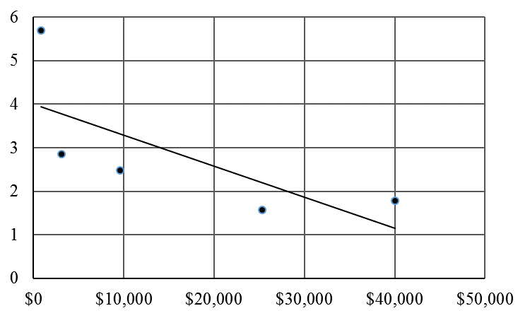
Annual earning capacity per woman
Birth rate
per 1000
women

(a) Explain why a linear fit to the data above is not the best fit for the data. (3)

(b) Sketch a scattergram and suggest the two possible variables for data with

(i) r = 0.2 (2)

(ii) r = -0.9 (2)

3. (8 marks)
Generate the first four terms of the sequences defined recursively below
(a) 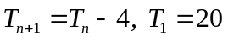 (2)

(b) 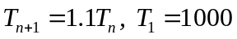 (3)

(c) 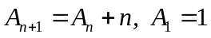 (3)

4. (13 marks)

(a) Consider the graph below:
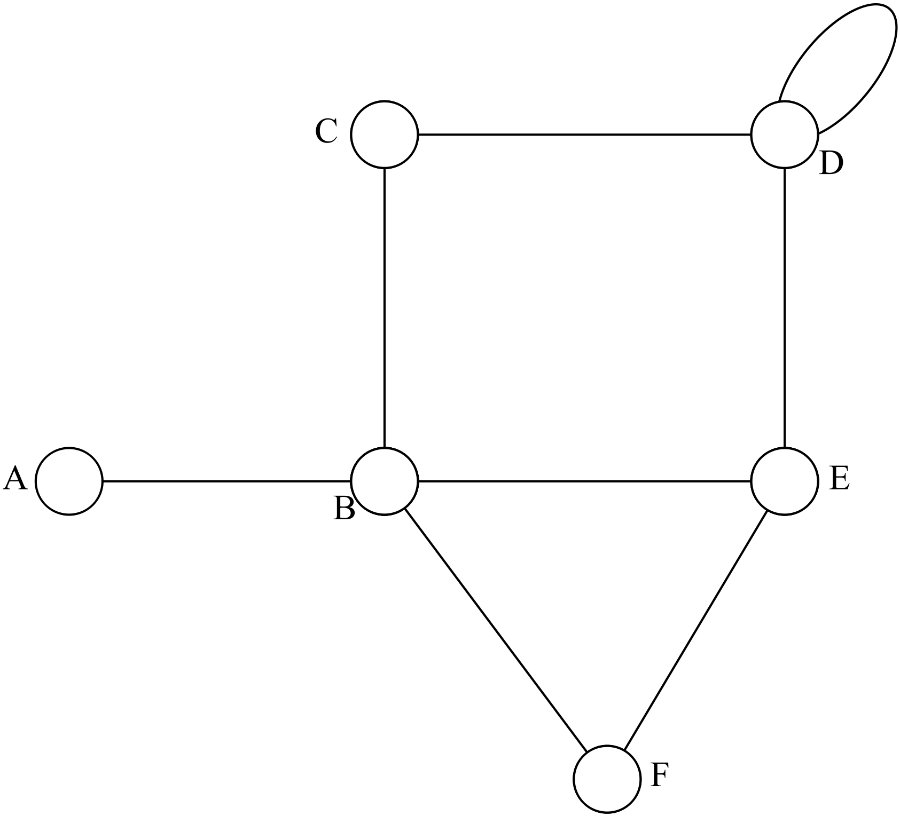

(i) Explain why the graph is not a simple graph. (1)

(ii) Write down the degree of vertex D. (1)

(iii) Name a subgraph of the graph that is a cycle. (1)

(iv) Explain why the graph is a semi-Eulerian graph. (2)

(b) Consider the graph below.
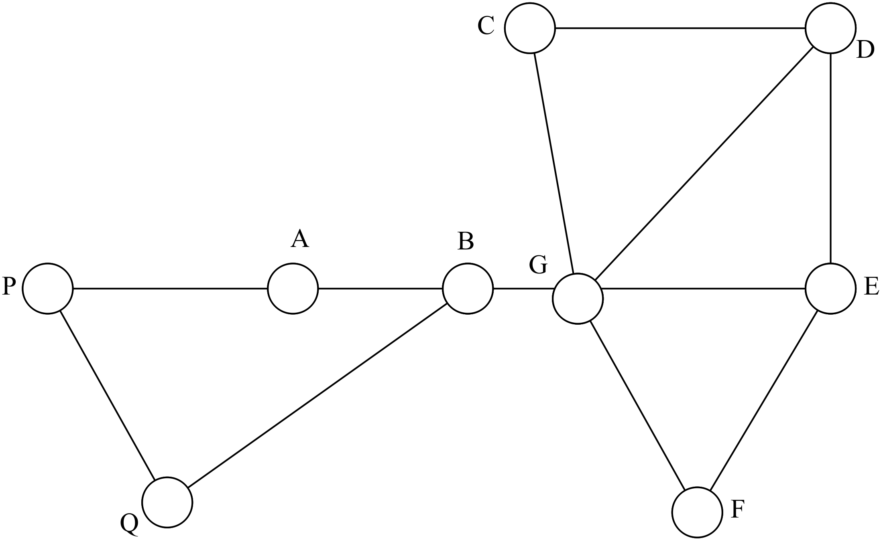

(i) Name a sub graph that is a closed trail. (2)

(ii) In the subgraph containing the vertices B,A,P and Q find and list a
semi-Hamiltonian path. (2)

(iii) Name a bridge. (1)

(c) Which of the following graphs are bipartite. Explain why. (3)

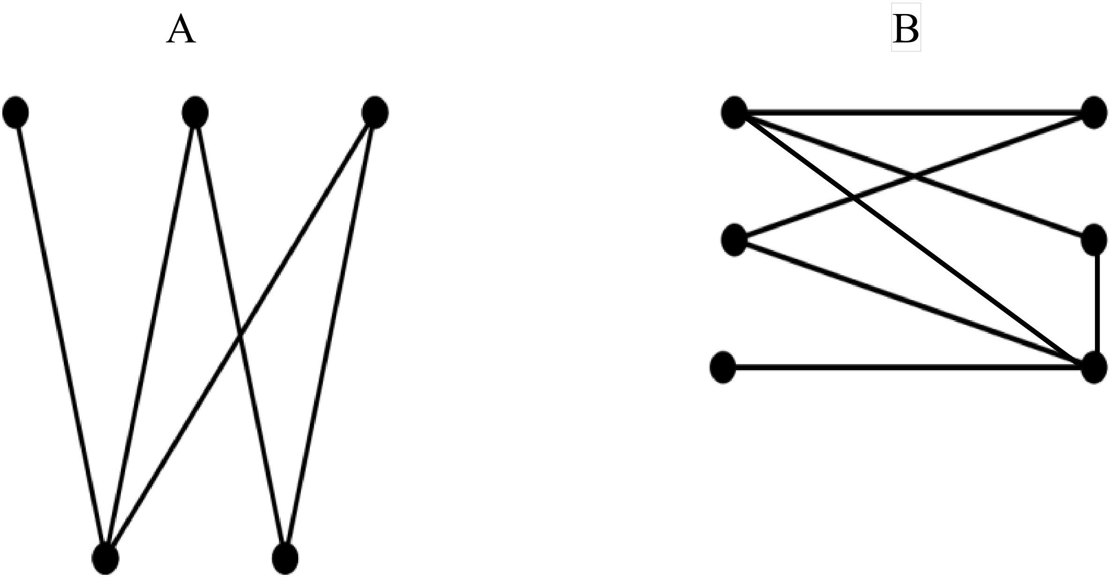

5. (12 marks)

(a) Four friends, A,B,C and D, email each other regularly. The number of emails
they sent to each other last week is shown in the adjacency matrix below.
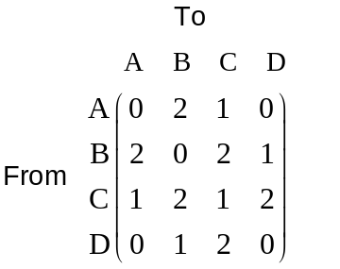

Illustrate the data on a graph below:

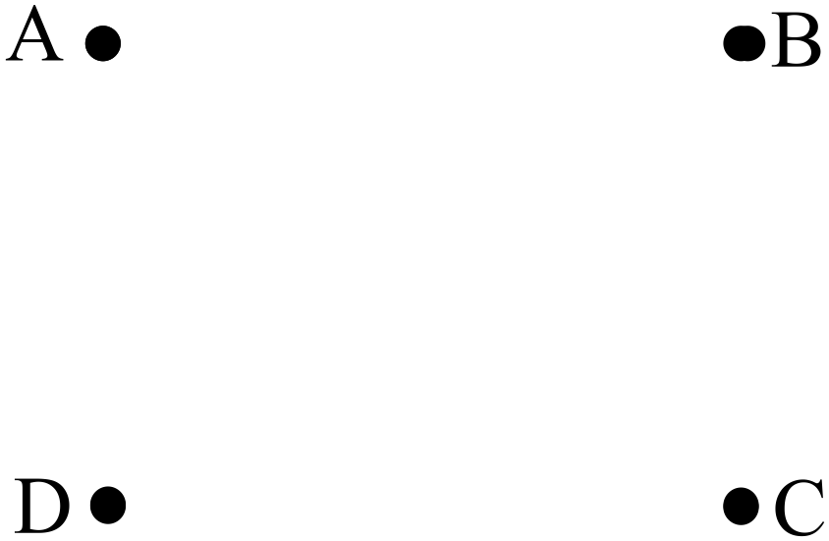
(3)

(b) Who sent an email to himself? (2)

(c) Who has the most communication with other people during this week? (2)

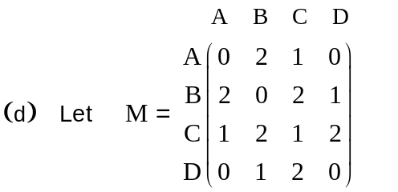

(i) Determine M². (4)

(ii) Is the two stage matrix necessary for everyone to be connected?
Explain. (1)

6. (8 marks)

Consider the three dimensional shape below.

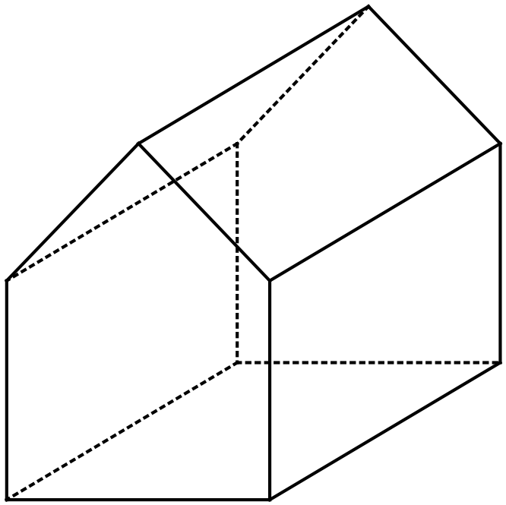

(a) Write down the number of vertices (V), faces (F) and edges (E).

V = F = E = (3)

(b) Use Euler’s formula 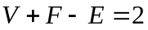 to determine whether or not the graph is
planar. (3)

(c) Sketch the two dimensional graph that corresponds to the three dimensional
shape above. (2)

END OF SECTION ONE

